Labdoo.org “autodeploy” and “auto install content” scripts
Table of Contents
Description 1
Autodeploy_18.sh : 1
install_content_labdoo.sh : 1
Where to obtain the latest version of the scripts 2
Copying the scripts after booting Labtix 2
Using autodeploy_18.sh 3
Question 1: Select the disk you want to ERASE and RESTORE the image in 4
Question 2: Select the disk you want to use as SOURCE 5
Question 3: In which disk you have the additional contents 5
Question 4: Select the image you want to restore 5
Question 5: Set a hostid automatically 6
Question 6: Possibility to skip the shredding 7
Question 7: Installation of additional contents 7
Question 8: what to do when the process finishes 8
Using install_content_labdoo.sh 9
Configuration Parameters 9
Using the script 9

Description
These 2 bash scripts are designed to automate the restoration of the images and the content of the lubuntu 18.04 based labdoo systems, allowing to perform a complete end-to-end sanitazion of the laptop in an unattended way.

Autodeploy_18.sh :
shredding of the harddrive (optional)
restoration of the selected image
configuration of a new hostid
deployment of all the additional contents of the languages you choose automatically

install_content_labdoo.sh :
restore all contents that fit on the HD (based upon a configurable “priority list” of the contents [web and xowa wikis] downloaded in the HD) that fit in the HD (leaving an acceptable [and configurable] margin of free space)

Where to obtain the latest version of the scripts
You can download or contribute to the code on the github project:
https://github.com/jprisab/labdoo_labtix
Or you can download the latest released stable version for labdoo ftp server:
http://ftp.labdoo.org/download/install-disk/
A version of these scripts is included as well in the Labtix iso CD but because of the release cycle of the Labtix solution it might not contain the latest corrections/features and hence it is recommended to always use the newer version of the scripts as described on the chapter “Copying the scripts after booting Labtix”

Copying the scripts after booting Labtix

for being sure I work with the latest version of the scripts [to be downloaded from http://ftp.labdoo.org/download/install-disk/ ](always may include some improvement or the addition of the extra content of a new language…) I always have them copied in the same USB HD where I have the Images and the content I want to restore

1.- Open the File Explorer
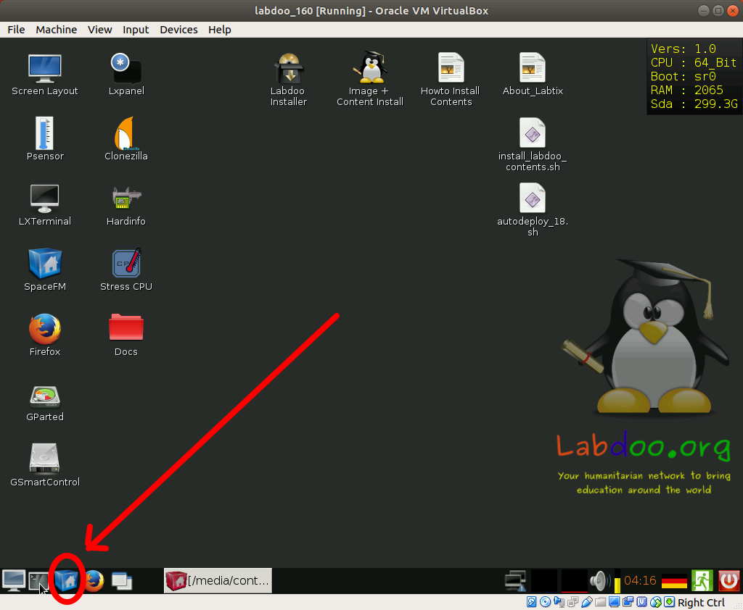

2.- copy the newer scripts to the desktop
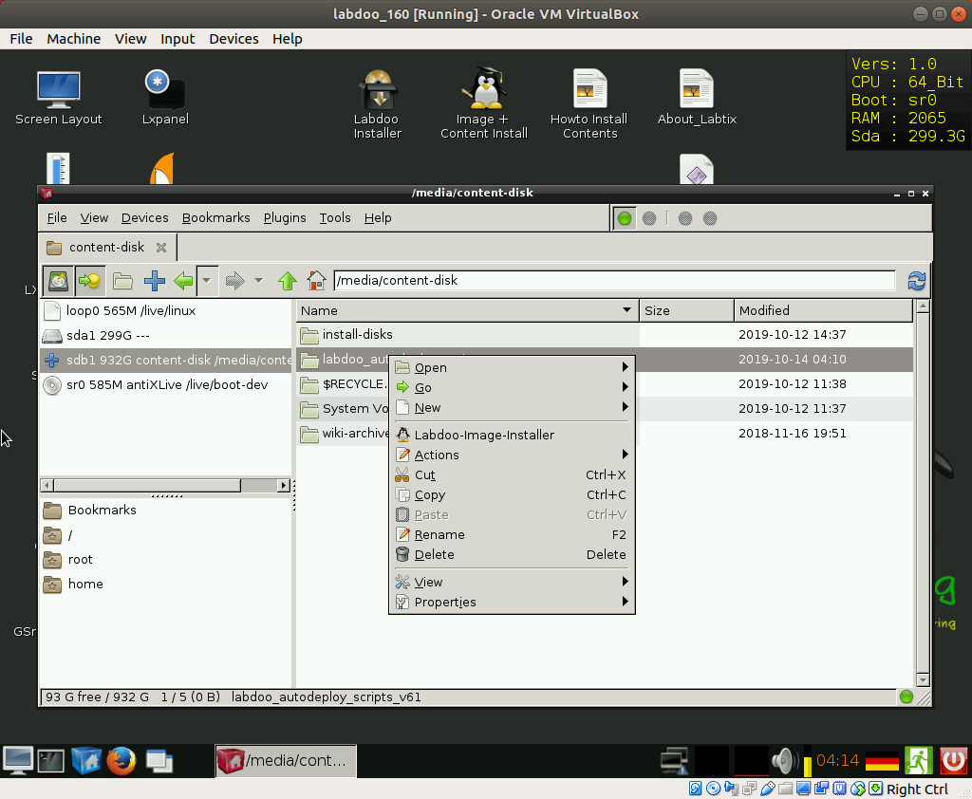
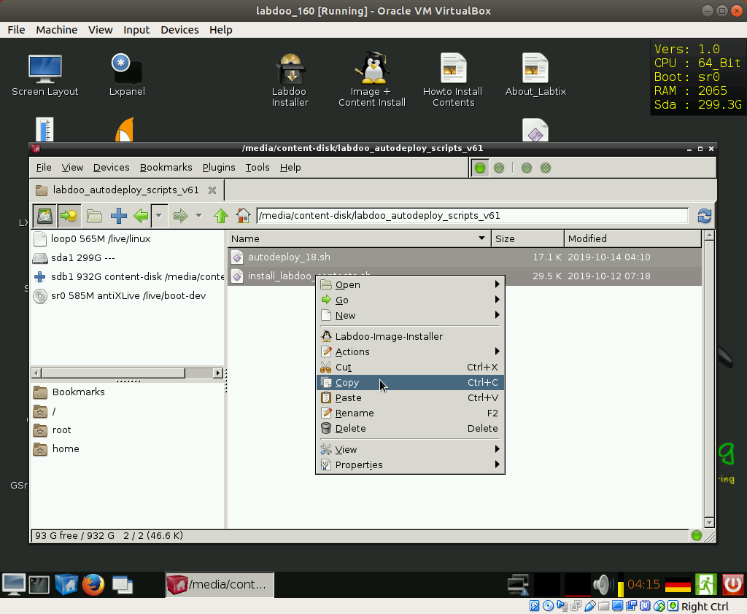

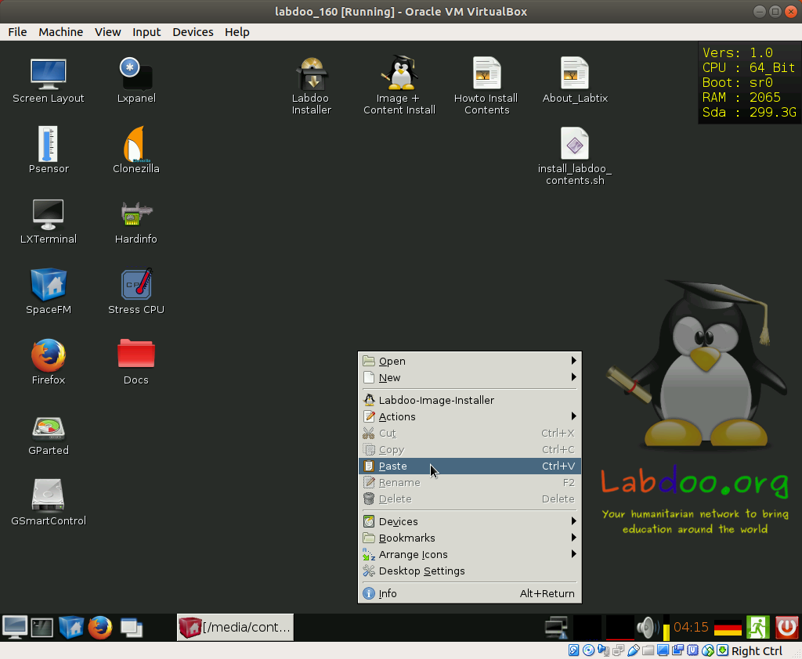

Using autodeploy_18.sh

Open the command console (come on, this is not rocket science...)

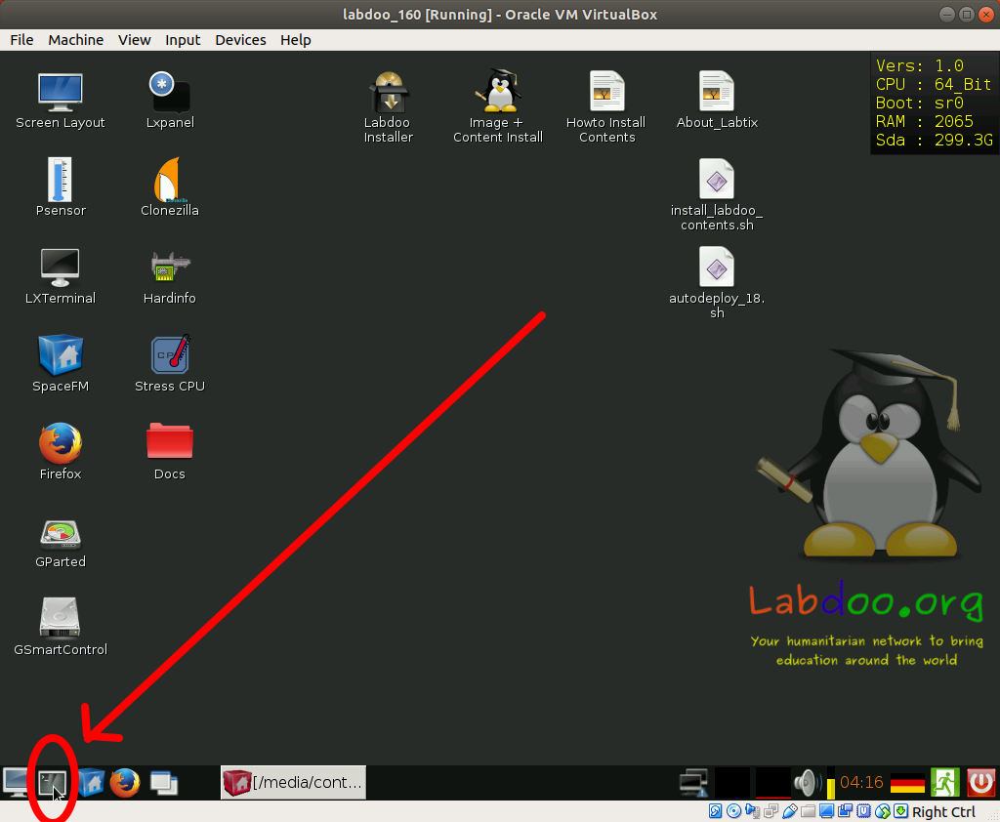

And then just type:
cd Desktop
press enter
bash autodeploy_18.sh
press enter
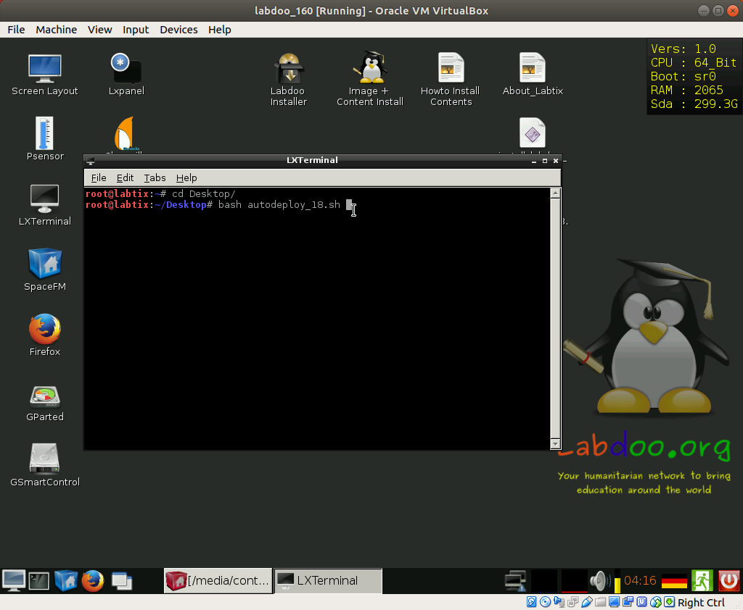

The script is running and you just have to answer carefully the questions (specially the first ones related to the units to delete and to restore from)

Question 1: Select the disk you want to ERASE and RESTORE the image in
this is easy, the script will show you the name of the units you see and the size, pick the one that is not the USB HD (and you should know how big is your USB HD… so the other one [99% of the time is the one also shown in the Labtix desktop in the corner up right (here you see it is indicating sda, and also I know that my USB HD is 931 Gb, so for sure I have to put sda)
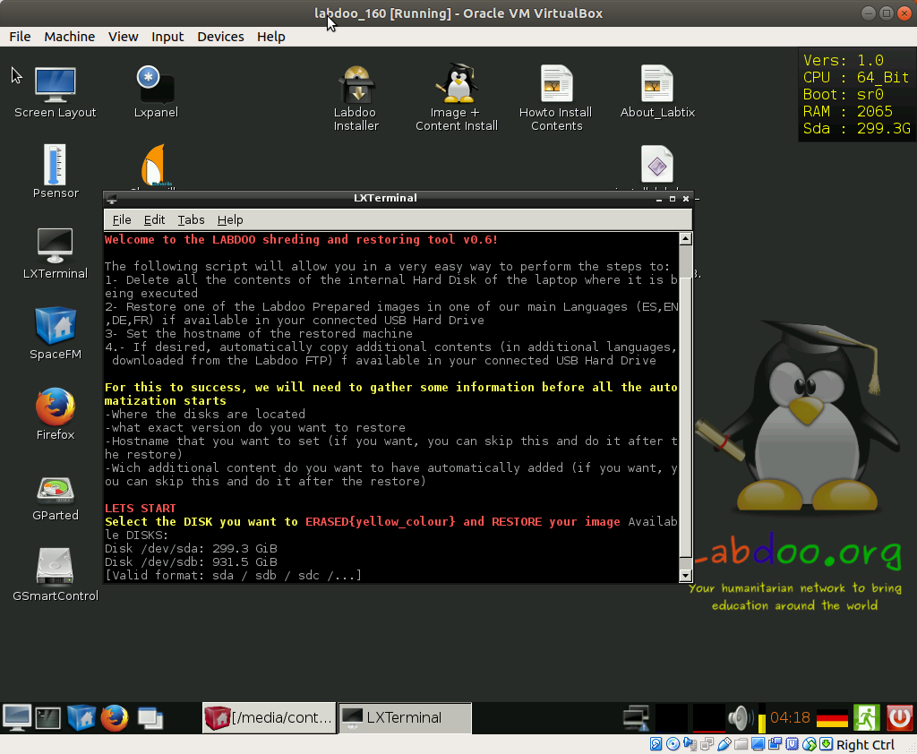

Question 2: Select the disk you want to use as SOURCE
So what is the unit where you have the images… in this case, as explained it will be sdb
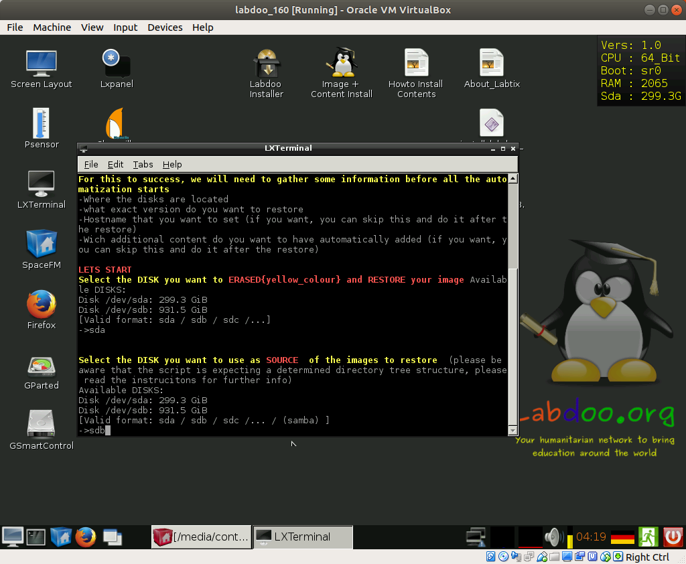

Question 3: In which disk you have the additional contents
If you have the additional contents also in a different USB HD (that of course at this time should already be plugged in), you should specify here the unit name of that disk (sdc? It will appear also listed...), if you have the contents in the same HD as the images, just press enter, the script will recognize them…

Question 4: Select the image you want to restore
The script will read the images available in the USB HD and list them, just select the number corresponding to the image you want to restore and click enter
By this time you should already know the naming convention for the images, but the script will remind you:
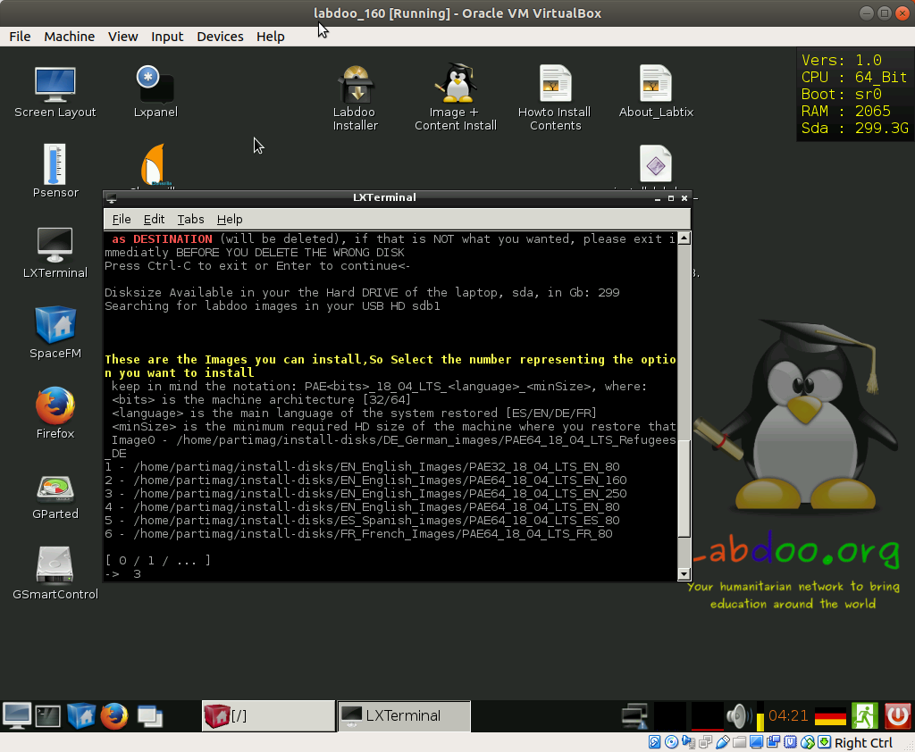

Question 5: Set a hostid automatically
The script asks you if you already want to assign a specific hostid during the restoration, this yway you will not need to change it afterwards in the system, just put the 5 numbers corresponding to the labdoo ID and click enter
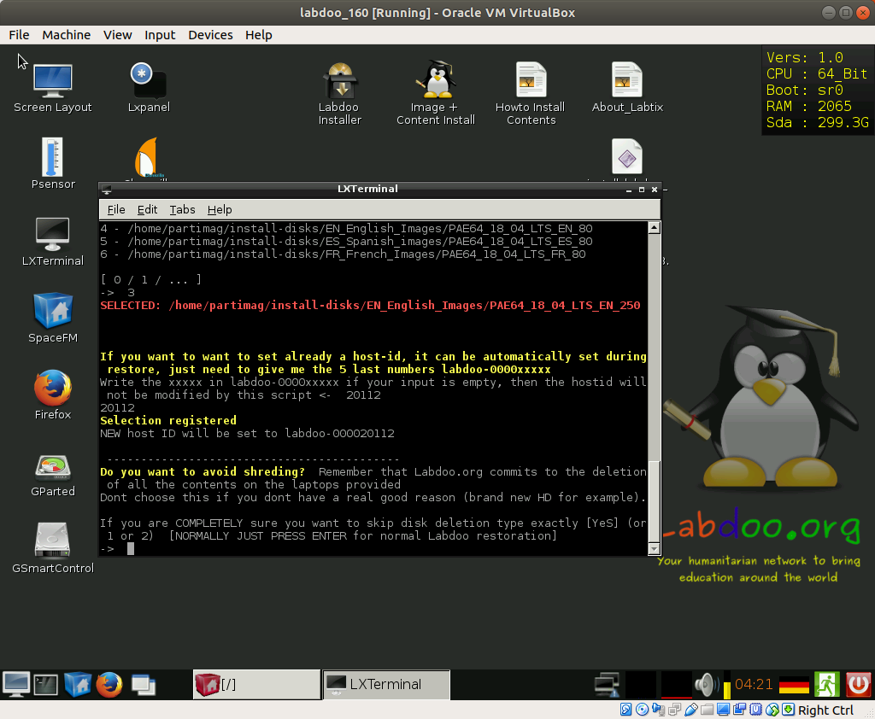

Question 6: Possibility to skip the shredding
Press directly Enter to leave the normal configuration (shredding the disk before restoring)
(ONLY Select something different if the laptop has already been erased previously or you are using a new HD, remember that deletion of data in donated laptops is mandatory)

Question 7: Installation of additional contents
Just enter the code languages of the additional contents you want to install separated by comma(in the example I select to install French and Swahili)
(very recommendable, to include as much educational content as possible!!) [it does it by automatically calling the install_content_labdoo.sh script]
currently supported languages:
[ES / EN / SW / AR / HI / DE / FR / NE / ID / PT / ZH / RU / RO / IT / FA / MY / HU / ZU / SR / UK]
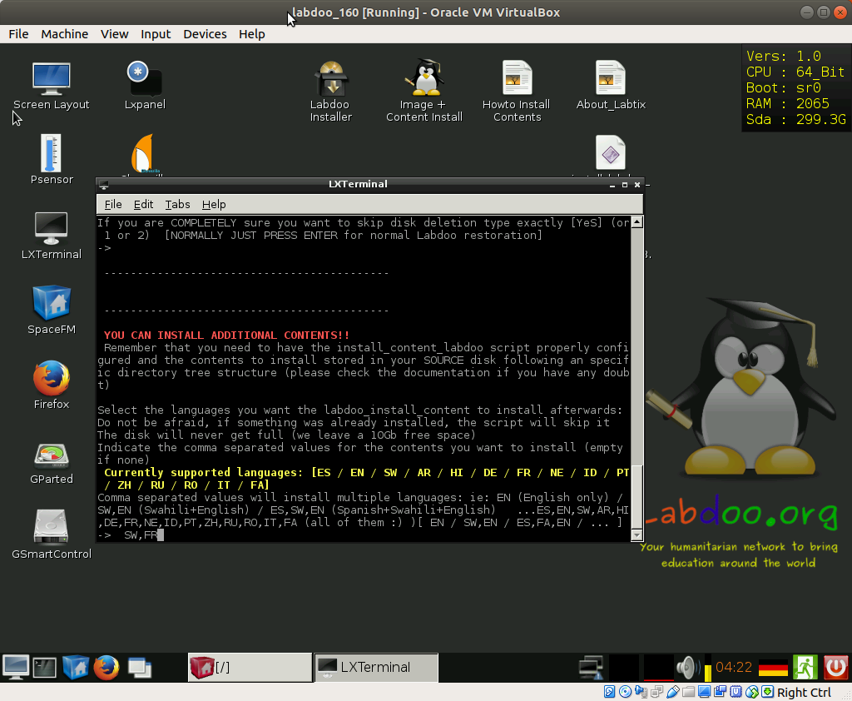

-

Question 8: what to do when the process finishes
I personally find it usefull sending the laptop to sleep, since it allows you to save power once finished, but also to wake it up afterwards and see how the process finished [as opposed of just having it shutted down]
Just select the option you prefer and press enter

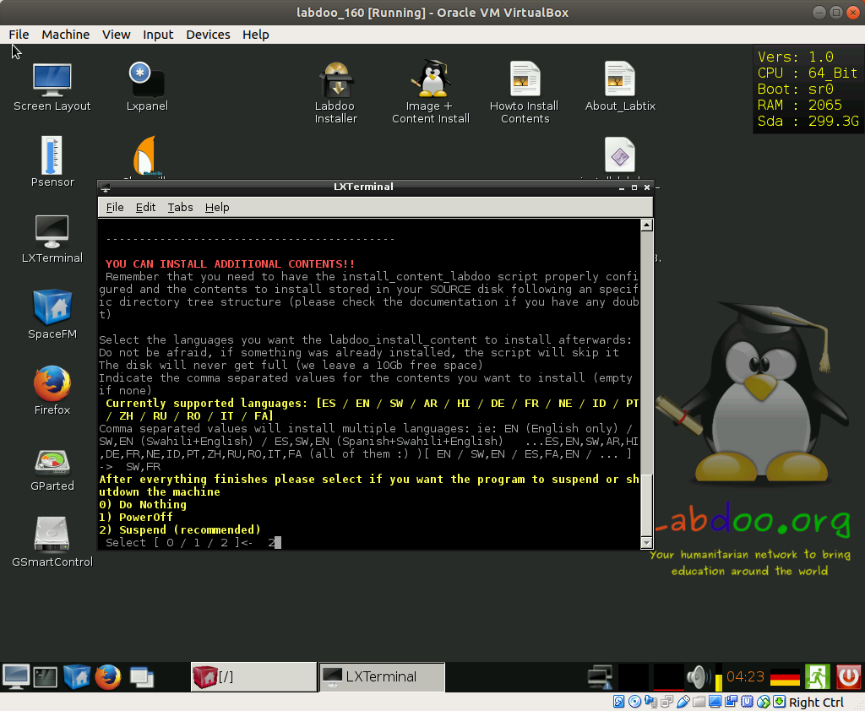

Using install_content_labdoo.sh
This script is totally automated and does not require any input from the user, if you like the configuration (or after you have setted to your taste) you just have to invoke it.
It will deploy the contents, adapt the index.html file so that only the installed content is showd in firefox and run once again the “set permissions correctly” script to avoid permission problems.
It will help you make sure that the students get all the possible content, after all, it was not so easy to bring the laptop to them

Configuration Parameters
You can reconfigure the following information about the content files you want to deploy but by default the configuration matches the images offered in the FTP server [and the ones that are installed in the “Stadard labdoo USB HD”] so do not change it if you dont really need:
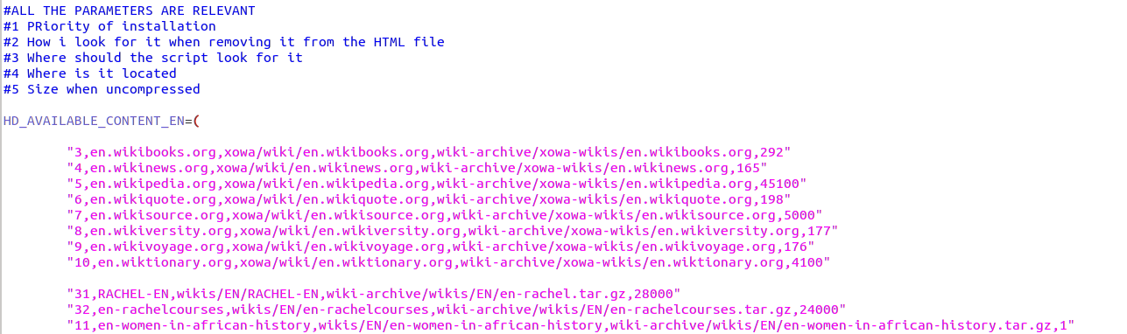
You might change at the priority order on which you want to have things deployed (until HD is full), I have given priority to the wikis and the Rachel contents as well as the “women in Africa history”, but you might change it at will (do not assign same number to different contents, otherwise one of then will be skipped)
Dont worry about the size, the script will try to install everything (if only 10 Gb are avialiable, and the first thing you have selected takes 20G, it will not break, will just skip it, and see if the next content in your priority list fits)
The installation will leave allways the space configured as MB_TO_BE_LEFT as free, you might change this value as well

Using the script
This is an easy one, plug the USB HD, invoke the script and go to sanitize in between a new laptop :)
Current supported languages:
[ES / EN / SW / AR / HI / DE / FR / NE / ID / PT / ZH / RU / RO / IT / FA / MY / HU / ZU / SR / UK]

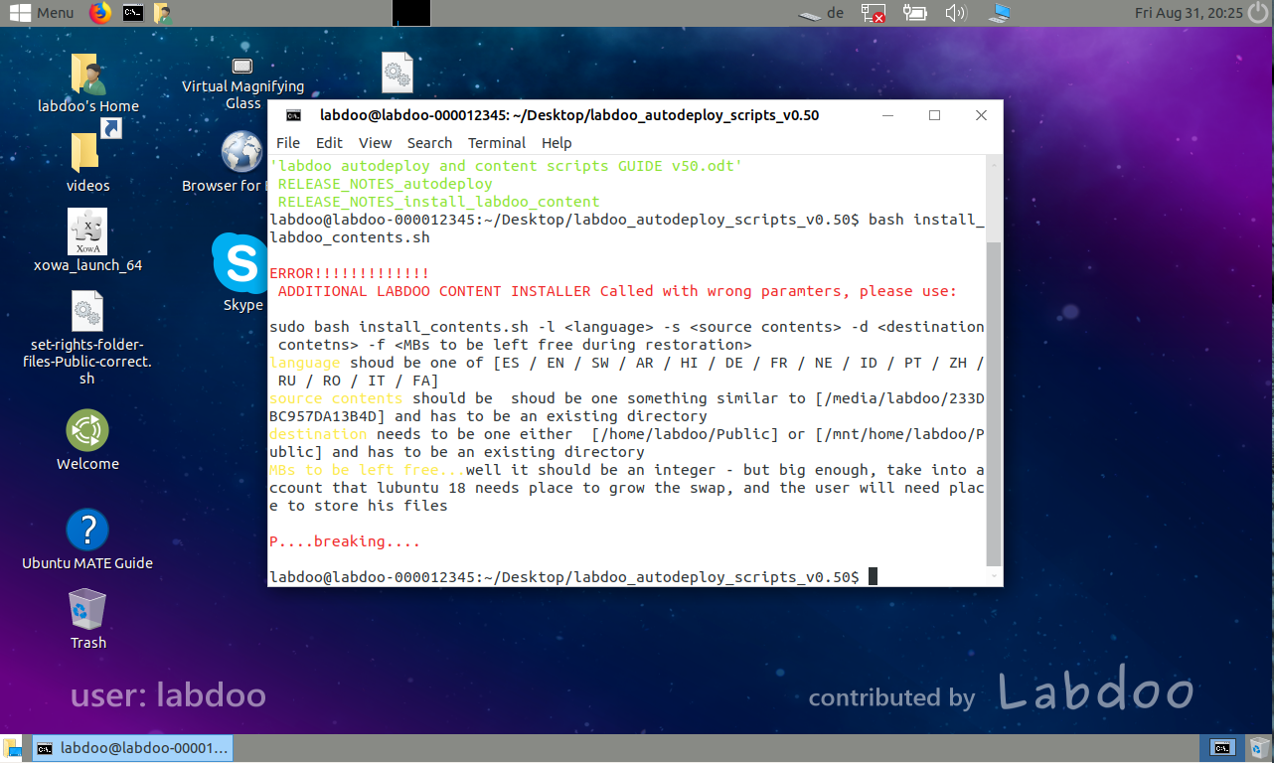

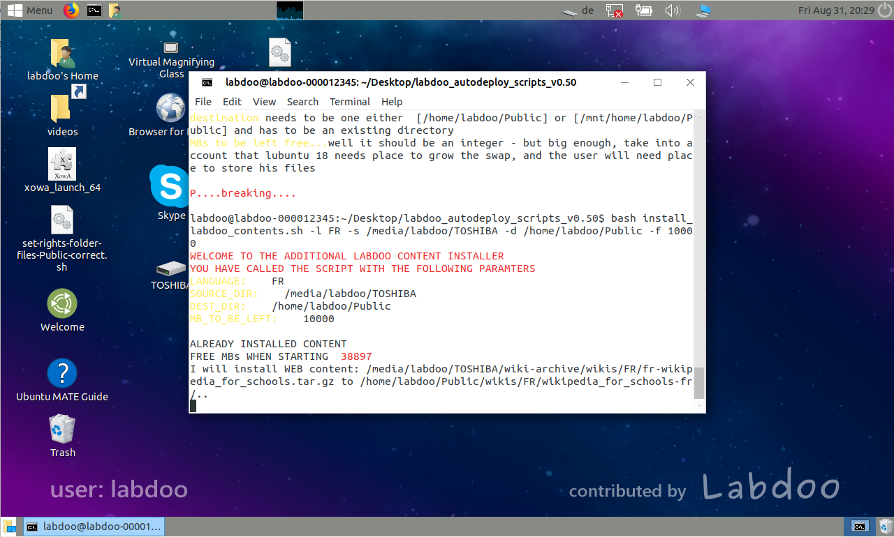

DISCLAIMER: we are under constant development
latest updated version of this document was for scripts version v0.62

contents of the package:
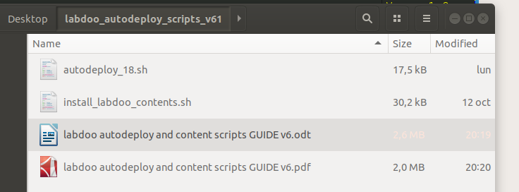
Please visit labdoo.org to keep up with the new developments and submit your ideas in the forums (and report any bug you may find), submit any doubt you might have to labdoo support wall
https://www.labdoo.org/content/labdoo-global-support-lgs/activities
Please feel free to modify any script to adapt to your requirements and preferences

